Given the root of a binary tree and a node u in the tree, return *the****nearest****node on the****same level****that is to the****right****of* u*, or return* null *if*u *is the rightmost node in its level*.

**Example 1:**

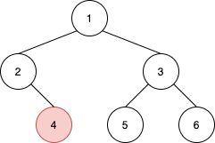

**Input:** root = [1,2,3,null,4,5,6], u = 4

**Output:** 5

**Explanation:** The nearest node on the same level to the right of node 4 is node 5.

**Example 2:**

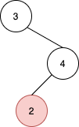

**Input:** root = [3,null,4,2], u = 2

**Output:** null

**Explanation:** There are no nodes to the right of 2.

**Example 3:**

**Input:** root = [1], u = 1

**Output:** null

**Example 4:**

**Input:** root = [3,4,2,null,null,null,1], u = 4

**Output:** 2

**Constraints:**

* The number of nodes in the tree is in the range [1, 105].
* 1 <= Node.val <= 105
* All values in the tree are **distinct**.
* u is a node in the binary tree rooted at root.